Sprint 6 – Code review, analysis, cleanup and acceptance tests

Sonarqube reports

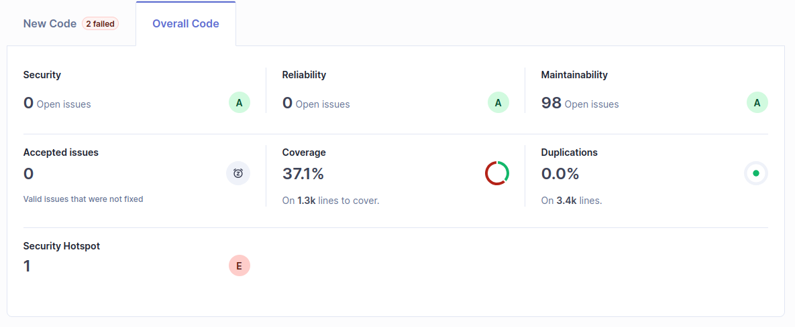
Quality gate currently set in SonarQube demands >80% coverage which we do not have.
There is 1 security warning related to unzipping the JAR to gather all translation files for reading. Maybe there would be a better way of handling this, the handling for this when using JAR archived application was done under pressure and also resulted in possibly unnecessary cognitive complexity in the LocaleSingleton class.
We have paid attention from the beginning to minimizing redundant or duplicate code and it has paid off now.

Maintainability:
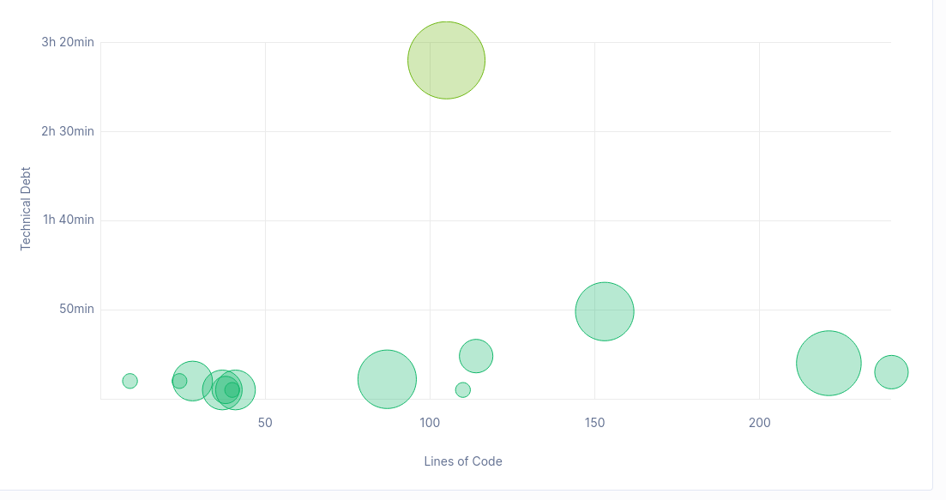
Mostly good with:
Info notices:
Many “todo” tags as there is a lot to still work on in the features or making sure of best practice solutions.
Two singleton classes which cause a notice as it should be made sure a singleton is absolutely necessary, which in our case might actually not be. Future to do would also include possibly rewriting of these singletons to normal objects and passing them through the program to where they are needed, if that would be the best solution.
Warnings:
Client is not in a namespace which leads to a low level warning
Multiple constants, final fields, which Sonarqube suggests setting as statics, not possible in all cases
Blocks of commented out code in pom.xml and few classes, these are left as they are yet unfinished methods but instead of removing them we would rather finish them when there is time
Mentions of using a generic exception instead of a dedicated one, we should probably create our own exceptions for some of these cases and maybe see if there is a certain exception to use instead of the general one
No parameterized type provided for the used generic. This might need going through with thought the interface and how the two different generics are used in all cases of implementing this interface. Would take a bit of time to make sure it is done correctly, we will add this to future developments too.
Unused method parameters for unfinished methods, e.g. removing and updating a user
High severity:
Multiple cases of literals used where Sonarqube demands constants. This seems overly strict as these are in some cases just logging messages or gui messages.
When using singletons getter to retrieve the token Sonarqube suggests turning the whole calling method to a static method which is not how the method is used, it seems to mix up getting the value from static class with setting the value there. We only read the token when creating queries, why would we turn those methods in to static methods? Might be worth a read.
One class has high cognitive complexity and probably should be redesigned
Few test cases which do not have assertions in date and number format localisations. More test cases should be done also to reach the 80% limit.

Metrics:
Lines of code: 2480
Functions: 296
Lines of code per function: 8.37
Code complexity:
Cyclomatic Complexity: 369
Cognitive Complexity: 142
Duplicate code: 0%
Unreachable code: 0%

View in client:
Major changes made:
Changed all system outs to logger all function and variable names to the same style changed IController to AbstractController because its Abstract

Model in client:
Added parameter types for generics, throwing exceptions when those forgotten, removal of commented out old lines of code. Many smaller fixes as per Sonarqube’s suggestions.

Maintainability:

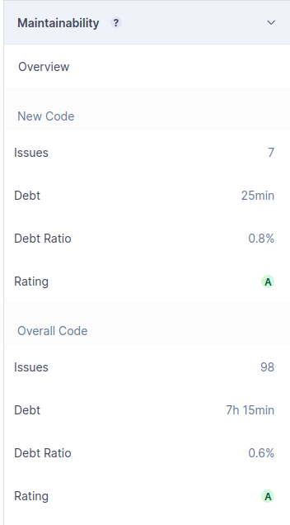

Coverage:
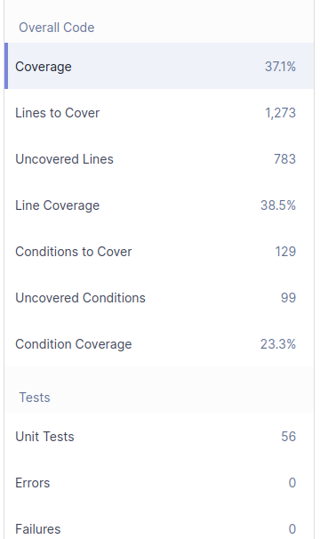

Size:
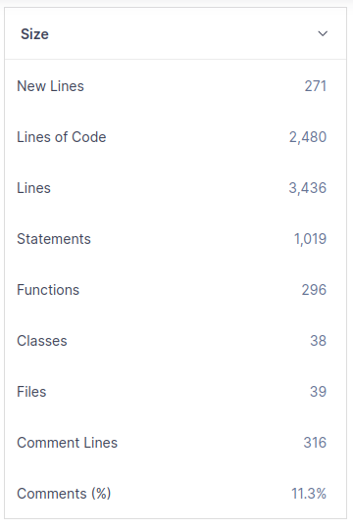

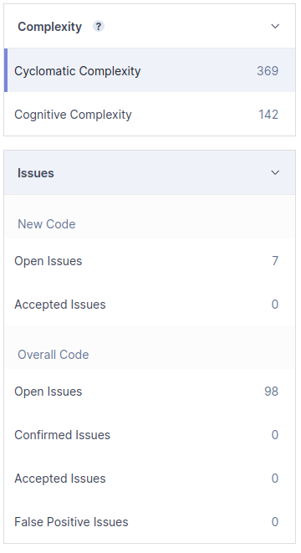

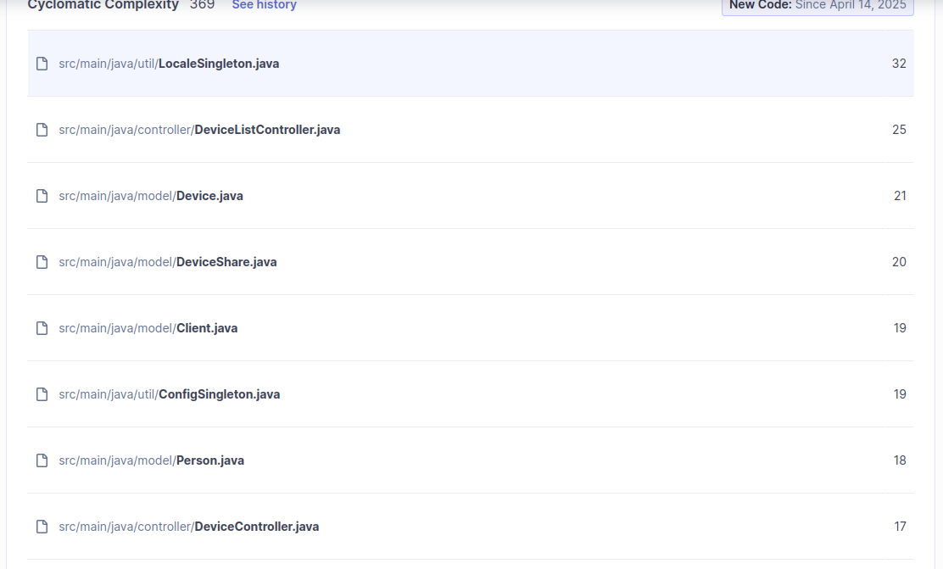

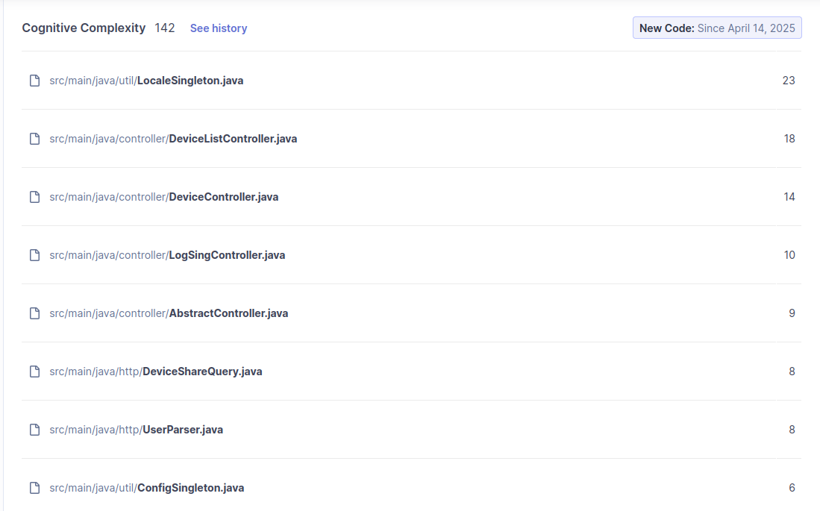

Acceptance Testing Plan: I-SPY-U
Purpose: This document outlines the plan for Acceptance Testing of the I-SPY-U application. It defines the criteria for acceptance and details the tests designed to verify that the application meets user requirements and is fit for purpose.
1. Define Acceptance Criteria
Based on the core requirements for I-SPY-U, the following criteria must be met for the project:

Criterion ID |  | Requirement Area |  | Category | Description |  | Verification Method
AC-01 |  | User Authentication |  | Functional | Users must be able to register a new account with a unique email, username and password. |  | Test case
AC-02 |  | User Authentication |  | Functional | Registered users must be able to log in using their correct credentials. |  | Test case
AC-03 |  | User Authentication |  | Functional | Users must receive a clear error message if login fails |  | Test case
AC-04 |  | My Devices  Viewing |  | Functional | Logged-in users must be able to see a list of their own devices under “My Devices” |  | Test case
AC-05 |  | My Devices  Interaction |  | Functional | Logged-in users must be able select a device from the “My Devices” list. |  | Test case
AC-06 |  | My Devices  Viewing |  | Functional | Upon selecting a device from "My Devices", its details must be displayed. |  | Test case
AC-07 |  | My Devices  Management |  | Functional | Logged-in users must be able to add a new device by clicking “Add a new device” button and inserting a unique UUID, name and description. |  | Test case
AC-08 | My Devices  Management |  | Functional |  |  | Logged-in users must be able to remove a device by clicking “Remove Device” button. | Test case
AC-09 | My Devices  Navigation |  | Functional |  |  | Logged-in users must be able to open a device by clicking “Open device” button. | Test case
AC-10 | My Device  Viewing |  | Functional |  |  | Upon opening a device, users must be able to see the last 15 logs. | Test case
AC-11 | My Device  Navigation |  | Functional |  |  | Logged-in users must be able to navigate to “Share” tab. | Test case
AC-12 | My Device  Viewing |  | Functional |  |  | Logged-in users must be able to view the list of users who have access to a device they own. | Test case
AC-13 | My Device  Management |  | Functional |  |  | Logged-in users must be able to share their device with email, selecting a role and description | Test case
AC-14 | My Device  Navigation |  | Functional |  |  | Logged-in users must be able to return to “My Devices” tab by clicking “Back to device list” button. | Test case
AC-15 | Share Devices  Navigation |  | Functional |  |  | Logged-in users must be able to navigate to “Share devices” tab | Test case
AC -16 | Share Devices  Viewing |  | Functional |  |  | Logged-in users must be able to see devices that have been shared with them under “Share Devices” tab | Test case
AC-17 | Share Devices  Intercation |  | Functional |  |  | Logged-in users must be able to select a device from the “Share Devices” list. | Test case
AC-18 | Share Devices  Viewing |  | Functional |  |  | Upon selecting a device from "Share Devices", its details must be displayed. | Test case
AC-19 | Share Devices  Management |  | Functional |  |  | Users can remove shared devices via the 'Remove Share' button. | Test case
AC-20 | Share Devices  Navigation |  | Functional |  |  | Logged-in users must be able to open a shared device by clicking “Open device” button | Test case
AC-21 | Share Device  Viewing |  | Functional |  |  | Upon opening a shared device, users must be able to see the last 15 logs. | Test case
AC-22 | Share Device  Navigation |  | Functional |  |  | Logged-in users must be able to navigate to “Share” tab. | Test case
AC-23 | Share Device  Interaction |  | Functional |  |  | Logged-in users must be able to edit the shared devices description shown to them. | Test case
AC-24 | Share Device  Navigation |  | Functional |  |  | Logged-in users must be able to return to “Share Devices” tab by clicking “Back to device list” button. | Test case
AC-25 | User Interface |  | Usability |  |  | Key functions (Login, Register, Add Device, Open Device, Share Device) should be easy to find and use. | Usability  testing
AC-26 | User Interface |  | Usability |  |  | Navigation between sections ("My Devices", "Share Devices", device views) should be clear. | Usability testing
AC-27 | Responsiveness |  | Perfomance |  |  | Selecting a device from "My Devices" list should feel responsive (target: < 3 seconds) | Performance testing
AC-28 | Responsiveness |  | Performance |  |  | Actions like adding, removing, or sharing a device should update the UI quickly (target: < 2 seconds). | Performance testing

2. Design Acceptance Tests
The following tests are designed to validate the Acceptance Criteria.

(A) Functional Tests
Test Case ID | Related AC(s) | Test Title | Test Steps | Expected Result
AT-F-01 | AC-01 | Successful Registration | 1. Navigate to register page. 2. Enter new unique email, username & password. 3. Click Register. | Account successfully created. User is redirected to “My Devices” tab
AT-F-02 | AC-02 | Successful Login | 1. Navigate to login page. 2. Enter registered username & correct password. 3. Click Login. | User logged in and redirected to “My Devices” tab.
AT-F-03 | AC-03 | Failed Login (Bad Password) | 1. Navigate to the Login page. 2. Enter registered username & incorrect password. 3. Click Login. | Login fails. User remains on the login page and error message "Invalid credentials" is shown.
AT-F-04 | AC-04 | View "My Devices" List | 1. Log in successfully. 2. Ensure the "My Devices" tab and list of devices is displayed. | A list containing devices owned by the logged-in user is displayed.
AT-F-05 | AC-05  AC-06 | Select Device from “My Devices” and view details | 1. Log in. 2. In "My Devices" tab click on a specific device entry in the list. | The device entry is visually indicated as selected (e.g., highlighted). Device details are shown.
AT-F-06 | AC-07 | Add new device | 1. Log in. 2. In "My Devices" click “Add a new device” button. 3. Enter unique UUID, name and description. 4. Click “Add device” button | Add device window closes and the device appears in the “My Devices” list
AT-F-07 | AC-08 | Remove a device | 1. Log in. 2. In "My Devices". 3. Select a device. 4. Click "Remove Device". 5. Confirm the removal | Remove device windows closes and the device is removed from “My Devices” list
AT-F-08 | AC-09  AC-10 | Open device from “My Devices” and view logs | 1. Log in. 2. In "My Devices". Select a device. 3. Click the “Open device" button. | User is navigated to the view for the selected device and displayed last 15 logs (or all if fewer)
AT-F-09 | AC-11  AC-12 | Navigate to owned device "Share" Tab and  view shared users | 1. Log in. 2. Open an owned device. 3. Click the "Share" tab within the device view. | The sharing management section for that device is displayed and a list of users who have access to the device is displayed (if any)
AT-F-10 | AC-13 | Share Owned Device with Another User | 1. Log in. 2. Open owned device, go to "Share" tab. 3. Enter email of another valid user, select role, enter description. 4. Click "Share". | *Success message. The newly added user appears in the list of users with access (verify via AT-F-12).
AT-F-11 | AC-14 | Navigate Back from Owned Device to List | 1. Log in. 2. Open an owned device. 3. Click the "Back to device list" button. | User is returned to the main "My Devices" list view.
AT-F-12 | AC-15 | Navigate to Main "Share Devices" Tab | 1. Log in. 2. Click the main "Share Devices" tab in the navigation. | The "Share Devices" view is displayed, intended to list devices shared with the current user.
AT-F-13 | AC-16 | View "Share Devices" List | 1. Log in. 2. Navigate to "Share Devices" tab. | A list of devices shared with the logged-in user by others is displayed.
AT-F-14 | AC-17  AC-18 | Select Device from "Share Devices" and view details | 1. Log in. 2. Navigate to "Share Devices" tab. 3. Click on a specific shared device entry. | The device entry is visually indicated as selected. Device details are displayed.
AT-F-15 | AC-19 | Remove a shared device | 1. Log in. 2. Navigate to "Share Devices". 3. Select a shared device. 4. Click the “Remove Share" button. | The device gets removed from the “Share Devices” list
AT-F-16 | AC-20  AC-21 | Open Device from "Share Devices" and view logs | 1. Log in. 2. Navigate to "Share Devices". Select a device. 3. Click the “Open device" button. | User is navigated to the view for the selected device and displayed last 15 logs (or all if fewer)
AT-F-17 | AC-22  AC-23 | Navigate to "Share" Tab (Shared Device), Edit description | 1. Log in. 2. Open a shared device. 3. Click the "Share" tab. 5. Edit description 6. Click save. | The sharing information section for that shared device is displayed and the description displayed is updated
AT-F-18 | AC-24 | Navigate Back from Shared Device to List | 1. Log in. 2. Open a  shared device.  3. Click the "Back to  device list” button |  | User is returned to the main "Share Devices" list view.

(B) Usability Tests
Test Case ID | Related AC(s) | Test Title | Test Scenario / Question for Tester | Expected Observation / Success Metric
AT-U-01 | AC-25 | Find Registration | (On login page) "Imagine you're a new user. How would you create an account?" | Tester easily locates and navigates to the Register page by clicking the “Sign up” tab.
AT-U-02 | AC-25  AC-13 | Find share unction | (Logged in, on “My devices) "How would you give another user access to this device?" | Tester quickly navigates to “Share” tab of the device.
AT-U-03 | AC-26  AC-16 | Basic Navigation | (Logged in, on "My devices") "Where would you look for devices others have shared with you?" | Tester correctly identifies and clicks the main "Share Devices" navigation tab

(C) Performance Tests
Test Case ID | Related AC(s) | Test Title | Test Steps | Expected Observation / Success Metric
AT-P-01 | AC-27 | Select device loading time | 1. Log in as a user with a device. 2. Select a device. 3. Observe loading time. | Details of the device appear (target: < 3 seconds.).
AT-P-02 | AC-28 | Remove device responsiveness | 1. Log in. 2. Select a device 3. Click on “Remove device” button. 4. Confirm removal.  5. Observe UI. | The device disappears from the list (target: < 2 seconds.)

